Chapter 3, Solution 28

At node c,
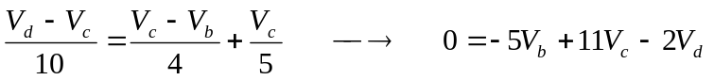 (1)
At node b,
(2)
At node a,
(3)
At node d,
(4)
In matrix form, (1) to (4) become
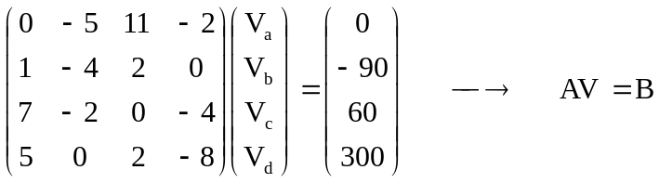
We use MATLAB to invert A and obtain

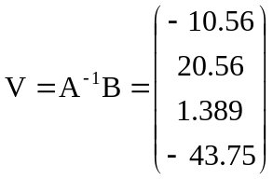
Thus,
V_{a} = –10.56 V; V_{b} = 20.56 V; V_{c} = 1.389 V; VC_{d} = –43.75 V.

